The user story is about assuming a person is playing the virtual golf games.

This is a simple golf game in which each hole is 230m from the user.

|  |
| --- |
| **Starts** |
| 1. Enter name 2. Reading instructions 3. playing game 4. quit the game |

|  |
| --- |
| **instructions** |
| Click “I” or “I”, you can read the role of the game and know about how to play the game. |

|  |
| --- |
| **Game play** |
| Click “P” or “p”, you can play the game.  Then it may have three clubs to choose.  If user choose F(farthest distance), it will hit about 80 to 120m.  If user choose M(medium distance), it will hit about 30m.  If user choose C(closest distance), it will hit about 10m.  The variable goal is the distance between the ball and the hole.  The variable distance is the distance that the ball went.  Score is the variable that how many times that you play until the ball is in the hole.  See “playing standard”  Don’t click other button. |

|  |
| --- |
| **Playing standard** |
| The standard par of the game is that the score is equal to 5.  If your score is less than 5,  you are under par.( Your level of playing golf game is high.)  If your score is 5,  you are on par.(Your level of playing golf game is medium.)  If your score is more than 5,  you are over par.(Your level of playing golf is low.) |

|  |
| --- |
| **Continue playing** |
| If the first turn is finished, you can still playing for the second time. The game loop of play is infinite. |

|  |
| --- |
| **Quit Game** |
| If you enter “q”, you can quit the game. |

Class golfinitial.java

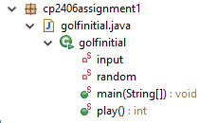

For example:

Player1:

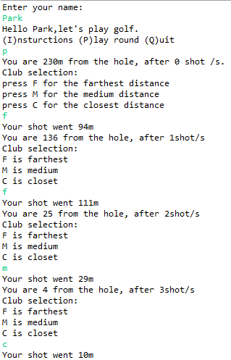

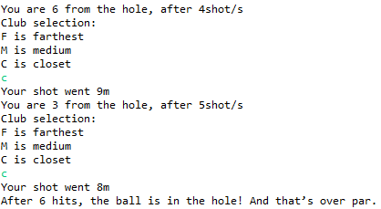

After 6 hits , the ball is in the hall. His playing standard is low.

Player2 is playing:

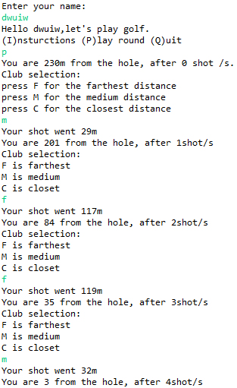

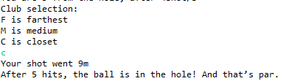

After 5 hits, the ball is in the hall. His playing standard is medium.

Example of player3:

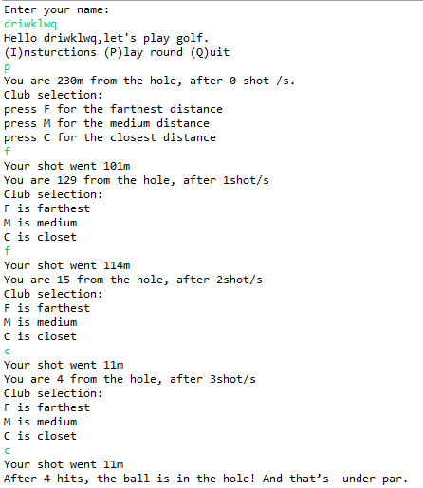

After 4 hits, the ball is in the hole. His playing standard is high.